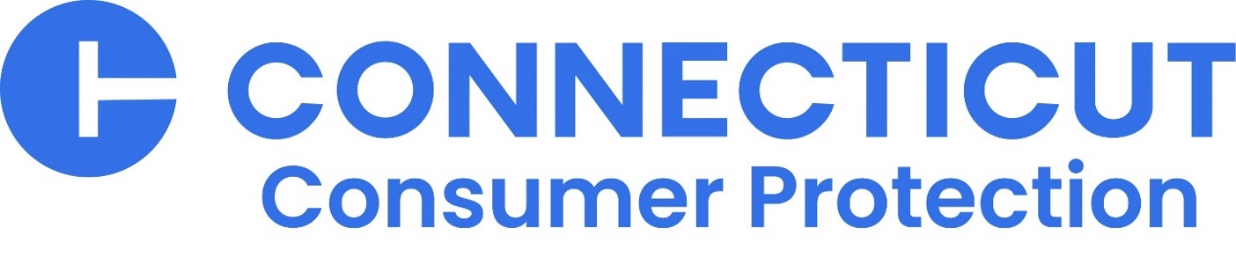

**Food Safety Warning/Recall Notice: Stew Leonard’s Apple Crisp Made with Honeycrisp Apples and No Sugar Added Apple Pie May Contain Undeclared Milk and Eggs**

*Stew Leonard’s has initiated a voluntary recall for several products containing undeclared milk and eggs, allergens that could cause illness.*

HARTFORD — The Connecticut Department of Consumer Protection Food, Standards and Product Safety Division (DCP) is warning the public that several apple pie products sold at Stew Leonard’s grocery stores contained milk and eggs, which were not disclosed on the labels.

Affected products were sold in Stew Leonard’s bakery department between August 28, 2023 – March 8, 2024.

The products were sold at Stew Leonard’s seven locations: Danbury, Norwalk, and Newington, CT; East Meadow, Farmingdale, and Yonkers, N.Y.; and Paramus, N.J.

Recalled products are:

* Apple Crisp Made with Honeycrisp Apples may contain undeclared milk
* No Sugar Added Apple Pie may contain undeclared eggs

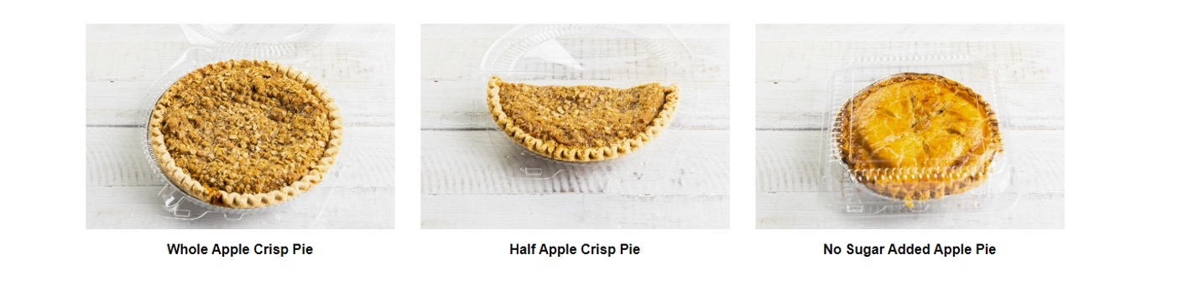

Stew Leonard’s has issued a voluntary recall for the products. Consumers who have an allergy or severe sensitivity to milk or eggs run the risk of a serious or life-threatening allergic reaction if they consume these products.  No illnesses have been reported to DCP to date.

Customers who have purchased these products should bring the product back to Stew Leonard’s customer service for a full refund.

###

Media Contact:  
Kaitlyn Krasselt   
[kaitlyn.krasselt@ct.gov](mailto:kaitlyn.krasselt@ct.gov)  
(860) 713-6019 (office)   
(860) 377-0246 (cell)