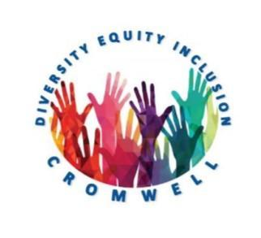

41 West Street, Cromwell CT 06416
860-632-3448

Diversity and Inclusion Committee

Monthly Meeting Minutes

Date: Monday, March 20, 2023 Time: 6:00 PM
Town Hall Multi-Purpose Room and Via Google Meet
Video call link: https://meet.google.com/fwz-qcra-skn

- Call to Order 6:02pm
- Approval of Agenda motion to approve by Erin, second by Alice. Passed unanimously.
- Approval of Previous Meeting’s Minutes
- Town Council Liaison Report no liaison in attendance
- Cromwell Public Schools District Equity Committee Liaison Report – ECS students created art about how they could represent themselves and change the world. The high school held an event that had a great turn out. Neighboring high schools are interested in the success of our high school group and are visiting to learn more and bring that information back to their schools.
- LGBTQ+ Committee update – no update
- Old Business
  - Update from attending previous town council meeting – Alice attended the last town council meeting and was able to talk with Mayor Fortenbach about working with LGBTQ+ to create a unity pole by the end of the school year. Committee members will create a rotation to always have a committee representative at town council meetings.
- New Business
  - CCD Summer Fest – CCD has decided they will not hold another event. They will be reaching out to other non-profit groups in town to see if they would be willing to work with the town in having the event.
  - CCD WINGS Project – CCD reached out to see if we want to participate in their project. Fellow non-profits will create wings that will then be put up and used for photo opportunities. Motion to participate by Erin, second by Carol. Passed unanimously. Erin will reply to CCD with our decision.
  - 50/50 Campaign – DEI members had an initial meeting with the 50/50 Campaign for more information on their plan to work with our community. Participation in the program is needed at a town council level and their services are at no cost to the town. Subcommittee has been created to finalize town-wide survey with a distribution date of April 17th. The survey will help us talk with the 50/50 Campaign.
  - ADA event funding – our funding is still available, and needs to be used by June 30th. A subcommittee will meet to come up with ideas to celebrate the ADA.
- Open Forum/For the Good of the Organization
  - CCD Rock Hunt – committee members are going to meet in April to paint rocks for the CCD Rock Hunt and Erin will deliver them to the designated place.
- Adjourn 7:19pm

Signed,
Erin Omicioli

